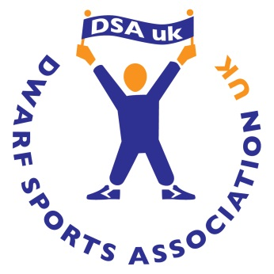
Dwarf Sports Association
2 Full Member Graduate Regional Officers
Full Time Flexi Hours with some weekend working
Minimum term of 6months, expanding to 12months should funding permit
£18,000 per annum pro rata

DSAuk is offering a new and exciting opportunity and plans to recruit 2 graduate calibre individuals for a minimum term of 6 months with a view to expand to 12 months should funding permit.
Both roles are reserved posts, with applicants needing to be a full member of the DSAuk in order to apply for these positions.
After a period of induction, you will be expected to work on your own initiative within the regions allocated to you, working towards achieving the objectives and plans set out in the working plan developed with DSAuk during your induction.
The role requires you to work flexibly, spending time familiarising yourself with the operation of the DSAuk main office and staff as well as building a network of external partners.

This is a full time flexi hours post and will require some weekend working, details of which will be discussed during the interview.

Download an application form and role outline directly from the Job Vacancy section on our webpage www.dsauk.org or for more information contact The Dwarf Sports Association Office on 01246-296485.

Closing date for applications is 4pm on September 12th 2014
Interviews will take place on 23rdSeptember at our office at Velocity point, Wreakes Lane, Dronfield, Derbyshire S18 1PN

DSAUK registered charity No.1041961

